44-560 Advanced Topics in Database Systems

Associative Entities KEY
- Sample data

STUDENT
StuId | FirstName | LastName | Gpa
111 | Joe | Johnson | 3.75
333 | Sally | Smith | 4.00
222 | Alex | Anderson

COURSE
CourseId | CourseTitle
44-230 | Fundamentals of Computer Science
44-460 | Database Systems
44-235 | Data Structures
44-317 | Management Information Systems

GradeInfo
StuId | CourseId | Grade
111 | 44-230 | A
111 | 44-317 | B
333 | 44-230 | A
333 | 44-235 | A
333 | 44-317 | A

- Create an ER model, using Visio – follow the steps given in the instructions.
- Model for products and vendors.
SOLUTION
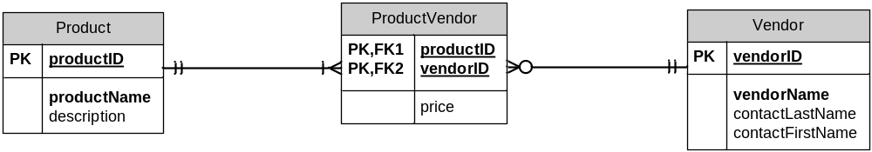

- Sample data for above model.

Vendor
vendorID | vendorName | contactLastName | contactFirstName
111 | Good Stuff | Brown | Amy
222 | Stuff To Go | Smith | John
333 | More Stuff | Anderson | Kim

Product
productID | productName | description
AAA | Gateway FPD 17” | 17” flat panel display
BBB | HP LaserJet G9 | LaserJet printer/copier
CCC | Microsoft Mouse A23 | Optical wireless mouse
DDD | Canon 4200 | InkJet printer

ProductVendor
productID | vendorID | price
AAA | 111 | 95.00
BBB | 111 | 150.00
AAA | 333 | 109.00
CCC | 333 | 35.00
DDD | 333 | 80.00

